Chapter X
Introduction to Entity Beans
One of the key benefits of EJB is the power to create entity beans. Entity beans are persistent objects that can be stored in permanent storage. This means you can model your business's fundamental, underlying data as entity beans. These are very different from session beans, which are business process components. We'll see exactly what this means in the pages to come.
In this chapter, we'll cover these topics:
- The basic concepts of persistence
- A definition of entity beans, from a programmer's perspective
- The features that entity beans have to offer
- How entity beans compare with session beans
- Entity bean programming concepts
This chapter is relatively theoretical, and it is meant to give you a deep foundation in entity bean programming concepts. For those of you with a traditional procedural programming background, entity beans can be a very tough topic to grasp. You may need to reread this chapter a few times to really understand how things work. Make sure you've read and understood the previous chapters in this book; our discussion of entity beans will build on the knowledge you've acquired so far. We'll use these concepts with hands-on code in Chapters X and X.
Persistence Concepts
Because entity beans are persistent objects, our discussion begins with a quick look at popular ways to persist objects.
Java Object Serialization
When you work with Java objects, in many cases you would like to capture the state of the object you're currently working with and save it to a permanent storage. One way to do this, as covered in Appendix X, is to use object serialization. Object serialization is an easy way to marshal an object graph into a compact representation. When you serialize an object graph, you convert the graph into a byte stream. You can then do anything you want to with that stream, such as push the data over the network (which is how Java RMI passes parameters over the network), or you can save the stream to storage, such as a file system, database or JNDI tree. For sophisticated persistence, however, object serialization falls short in many areas.
For example, let's say we store a million serializable bank account objects onto a file system. We do this by converting the objects to their bit-blob representation and then storing the bytes on disk. Let's say we then want to retrieve all bank accounts that have balances over $1000. To do this with serialization, we'd have to load each and every bank account serialized bit-blob from the disk, construct the corresponding object, and then execute a method query on the object to determine if the balance is over $1000. We might want to perform more advanced queries as well, such as retrieving all checking accounts that have been inactive for six months. There is no efficient way to do this with object serialization.
In general, querying objects stored using object serialization is very expensive and cumbersome. Submitting queries against business data is an absolute necessity for large-scale applications, which makes simple object serialization unsuitable for persistent storage. While object serialization has its purpose, it is best used in restricted domains, such as for network communications and simple persistence. For EJB, we'll need a more robust persistence mechanism to address more complex querying operations.
Object-Relational Mapping
Another popular way to store Java objects is to use a traditional relational database, such as Oracle or Microsoft SQL Server. Rather than serialize each object, we could decompose each object into its constituent parts and store each part separately. For example, for a bank account object, the bank account number could be stored in one relational database row, while the bank account balance could be stored in another row. When you save your Java objects, you would use JDBC or SQL/J to map the object data into a relational database. You could also store the name of the Java class that this data corresponds to, so that you know which class to instantiate when reading the object back from the database. When you want to load your objects from the database, you'd first instantiate an object from that class, read the data in from the database, and then populate that object instance's fields with the relational data read in. This is shown in Figure X.X.
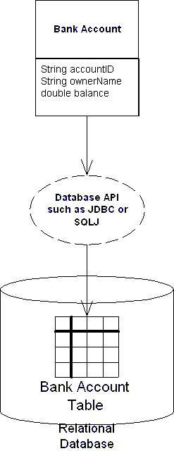
Figure X.X Object-relational mapping.
This mapping of objects to relational databases is a technology called object-relational mapping. It is the act of converting and unconverting in-memory objects to relational data. An object-relational (O/R) mapper may map your objects to any kind of relational database schema. For example, a simple object-relational mapping engine might map a Java class to a SQL table definition. An instance of that class would map to a row in that table, while fields in that instance would map to individual cells in that row. This is shown in Figure X.X. You'll see more advanced cases of O/R mapping in Chapter X.
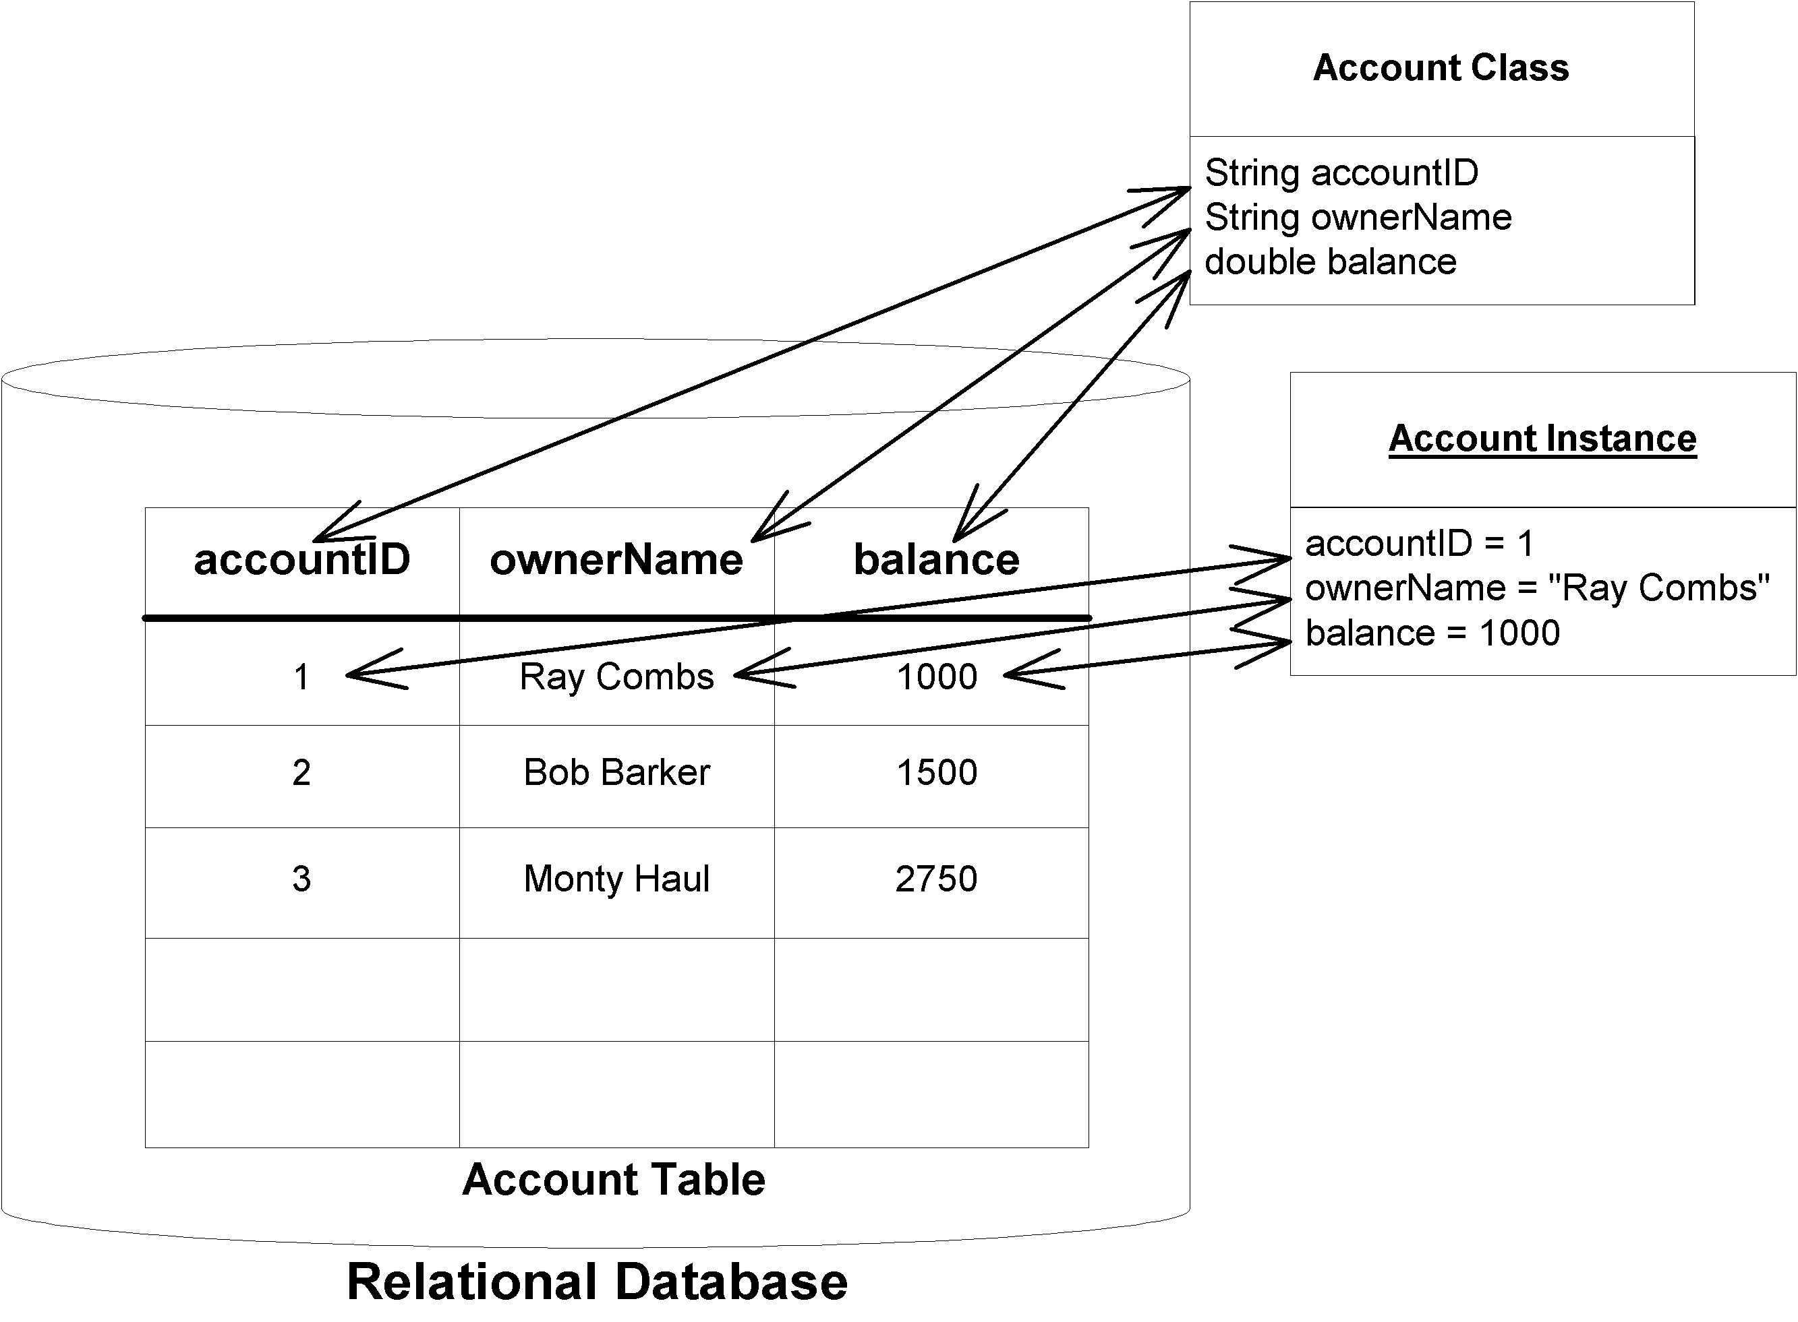
Figure X.X Trivial object-relational mapping
Object-relational mapping as a persistence mechanism is a much more sophisticated mechanism of persisting objects than simple object serialization. By decomposing your Java objects as relational data, you can issue arbitrary queries for information. For example, you can search through all the database records that have an account balance entry greater than $1000 and load only the objects that fulfill this query. More advanced queries are also possible. You can also visually inspect the database data since it is not stored as bit-blobs, which is great for debugging or auditing.
Mapping of objects to relational data can be done in two ways. You can either hand-craft this mapping in your code or use an object-relational mapping product such as WebGain's TOPLink or Sun's JavaBlend to automate or facilitate this mapping. Today, most users hand-craft the mapping using a database access API such as JDBC or SQL/J. Because the cost of developing and maintaining an object-relational mapping layer is significant, it is likely that the object-relational mapping products will be adopted as they mature.
Object Databases
An object database management system (ODBMS) is a persistent store that holds entire objects. In an object database, your objects are first-class citizens in the database. This means there is no O/R mapping layer—your Java objects themselves are stored as whole objects. Because of this, you don't need to program to a relational database API—rather, you program to the object database's API. This means you can sidestep object/relational mapping, resulting in simplified data access code.
Most object databases (and O/R mapping products) provide facilities to query persisted objects by using an object query language (OQL). OQL is a nice high-level interface that allows you to query object properties for arbitrary characteristics. It also adds a layer of abstraction from relational database queries.
In addition to OQL-based queries, object databases support relationships between objects. You could define a relationship between a Bank Account object and a Customer object and transparently navigate between them. The transparent navigation makes it easy to navigate the object model and has excellent performance when compared to SQL-based joins that are needed to perform equivalent operations in relational databases.
Object databases also have very predictable performance and scalability. They offer very strong integrity and security, and they provide an excellent store for complex persistent objects. There are certain applications that go really well with object databases (geospatial or CAD/CAM, for example) that are complete misfits for relational databases. There are other applications that map easily to relational databases, such as most business applications. For simple high-volume business transactions, relational databases typically scale better than object databases.
ObjectStore, Versant, and POET are a few of the current vendors who provide object database technology. Unfortunately, object database products have not yet been fully embraced by the industry. Although they are very useful for certain applications, object databases are currently limited because they don’t have very many associated tools, such as reporting, tuning, and management tools.
Now that we've whetted your appetite with persistence mechanisms, let's take a look at how entity bean persistent objects are used in an EJB multitier environment.
What Is an Entity Bean?
In any sophisticated, object-oriented multitier deployment, we can draw a clear distinction between two different kinds of components deployed:
Application logic components. These components are method providers that perform common tasks. Their tasks might include the following: @@@Comp: the following BLs are sublists of UL., and the following two BTs are part of this first UL@@@
- Computing the price of an order
- Billing a customer's credit card
- Computing the inverse of a matrix
Notice that these components represent actions (they're verbs). They are well suited to handle business processes.
Session beans model these application logic components very well. They often will contain interesting algorithms and logic to perform application tasks. Session beans represent work being performed for a user. They represent the user session, which includes any workflow logic.
Persistent data components. These are objects (perhaps written in Java) that know how to render themselves into persistent storage. They use some persistence mechanism, such as serialization, O/R mapping to a relational database, or an object database. These kinds of objects represent data—simple or complex information that you'd like saved. Examples here include the following: @@@Comp: The following BLs and next two BTs are part of this UL@@@
- Bank account information, such as account number and balance
- Human resources data, such as names, departments, and salaries of employees
- Lead tracking information, such as names, addresses, and phone numbers of prospective customers that you want to keep track of over time
Notice that these components represent people, places, and things (they're nouns). They are well suited to handle business data.
You might question the need for such persistent data components. Why should we deal with our business data as objects, rather than dealing with raw database data, such as relational rows? The answer is that it is very handy to treat data as objects because they can be easily handled and managed and because they are represented in a compact manner. We can group related data together in a unified object. We associate some simple methods with that data, such as compression or other data-related activities. We can also gain implicit middleware services from an application server, such as transactions, network accessibility, and security.
Entity beans are these persistent data components. Entity beans are enterprise beans that know how to persist themselves permanently to a durable storage such as a database or legacy system. They are physical, storable parts of an enterprise. Entity beans store data as fields, such as bank account numbers and bank account balances. They also have methods associated with them, such as getBankAccountNumber() and getAccountBalance().
In some ways, entity beans are analogous to serializable Java objects. Serializable objects can be rendered into a bit-blob and then saved into a persistent store; entity beans can persist themselves in many ways, including serialization, O/R mapping, or object database persistence. There is nothing in the EJB specification that dictates any particular persistence mechanism.
Entity beans are very different from session beans. Session beans model a process or workflow (actions that are started by the user and that go away when the user goes away). Entity beans, on the other hand, contain core business data, such as product information, bank accounts, orders, lead tracking information, customer information, and more. An entity bean does not perform complex tasks or workflow logic, such as billing a customer. Rather, an entity bean is the customer itself. Entity beans represent persistent state objects (things that don’t go away when the user goes away).
For example, you might want to read a bank account data into an entity bean instance, thus loading the stored database information into the in-memory entity bean instance's fields. You can then play with the Java object and modify its representation in memory because you're working with convenient Java objects, rather than bunches of database records. You can increase the bank account balance in-memory, thus updating the entity bean's in-memory bank account balance field. Then you can save the Java object, pushing the data back into the underlying store. This would effectively deposit money into the bank account.
NOTE
The term entity bean is grossly overused. Sometimes it refers to an in-memory Java object instance of an entity bean class, and sometimes it refers to database data that an in-memory Java object instance represents. To make the distinction clear, we introduce two new terms:
The entity bean instance is the in-memory view into the database. It is an instance of your entity bean class.
The entity bean data (or data instance) is the physical set of data, such as a bank account record, stored in the database.
In summary, you should think of an entity bean instance as the following:
- An in-memory Java representation of persistent data
- Smart enough to know how to read itself from a storage and populate its fields with the stored data
- An object that can then be modified in-memory to change the values of data
- Persistable, so that it can be saved back into storage again, thus updating the database data
Files Included with Entity Beans
Let's take a look at the files that make up an entity bean component:
The entity bean class is a Java class that models persistent data. An entity bean class maps to an entity definition in a database schema. For example, an entity bean class could map to a relational table definition. In this case, an entity bean instance of that class would map to a row in that table. Your entity bean class can expose simple methods to manipulate or access that data, such as a method to decrease a bank account balance. Like a session bean class, EJB also requires that an entity bean class must fill in some standard callback methods. The EJB container will call these methods appropriately to manage the entity bean.
The entity bean's remote interface is the interface to your beans on which clients invoke. In it, you should place each of your entity bean's business method signatures. Your EJB container vendor provides tools to implement this remote interface; the implementation is the entity bean's EJB object. The EJB object represents a layer of indirection between the client and the bean. Clients invoke directly on the EJB object, rather than on the entity bean itself. Because the EJB object is part of the container, it contains logic to intercept method calls and perform management tasks on the bean instance as needed. This is exactly the same concept that we learned for session beans.
The entity bean's home interface is the interface clients use to create, find, and destroy entity bean EJB objects. In it, you should put the different possible methods you'd like available to create a new entity bean EJB objects, and to find or destroy old ones. Your EJB container vendor provides tools to implement this home interface; the implementation is the entity bean's home object. This home object is the factory for your EJB objects. To find the home object, your clients must perform a JNDI lookup. This is exactly the same concept that we learned for session beans.
The entity bean's local interface and local home interface are higher performing versions of the remote interface and home interface, respectively. Optimizations occur such as passing parameters by reference, no network overhead, and no stub nor skeleton. You can only call these from a client that is co-located in the same JVM.
The entity bean's primary key class is a file that exists only with entity beans, not session beans nor message-driven beans. A primary key class is a unique identifier for your entity bean. Primary keys make every entity bean different. For example, if you have 1 million different bank account entity beans, each bank account needs to have a unique ID (such as a bank account ID string) that can never be repeated in any other bank account. A primary key is an object that may contain any number of attributes. This could be whatever data necessary to uniquely identify an entity bean data instance. In some advanced cases, when the entity bean represents a complex relationship, the primary key might be an entire object. EJB gives you the flexibility to define what your unique identifier is by including a primary key class with your entity bean. The one rule is that your primary key class must be serializable and follow the rules for Java object serialization. We present the rules for object serialization in Appendix X.
The entity bean's deployment descriptor contains a list of properties that should be used by the container on deployment. Deployment descriptors inform your container about your bean. You can also define environment properties to allow end users to customize your entity bean on deployment. There are some new deployment descriptors that are particular to entity beans; we'll find out about them later.
When you write your entity beans, you can write them as local, remote, or both. Then, in order to ship your entity beans, you should package these files in an Ejb-jar file, which is a simple Java archive. Include a manifest file in the Ejb-jar for locating your bean within the jar, and you've got a shippable entity bean component.
Features of Entity Beans
Let's now take a look at the features that entity beans sport. We'll use our understanding of session beans as a frame of reference for learning entity beans.
Entity Beans Survive Failures
In Chapter X, we pointed out that session beans have a lifetime of a client session. This means that session beans live and die for about the same amount of time that a client is around. When the client leaves, the session bean may be destroyed. And because session beans are short-lived and have the lifespan of a client's session, they are typically destroyed in a catastrophic event, such as a JVM crash.
In contrast, entity beans are long lasting. They survive critical failures, such as application servers crashing, or even databases crashing. This is because entity beans are just representations of data in a permanent, fault-tolerant underlying storage. If a machine crashes, then the entity bean can be reconstructed in memory again. All we need to do is read the data back in from the permanent database and instantiate an entity bean Java object instance whose fields contain the data read-in from the database.
This is a huge difference between session and entity beans--entity beans have a life cycle much longer than a client’s session, perhaps years long, depending on how long the data sits in the database. In fact, the database records representing an object could have existed before the company even decided to go with a Java-based solution because a database structure can be language-independent. This makes sense-- you definitely would want your bank account to last for a few years, regardless of technology changes in your bank, wouldn't you?
Entity Bean Instances Are a View into a Database
When you load entity bean data into an in-memory entity bean instance, you read in the data stored in a database so that you can manipulate the data within a Java Virtual Machine. However, you should think of the in-memory object and the database itself as really being one and the same. This means if you update the in-memory entity bean instance, the database should automatically be updated as well. You should not think of the in-memory entity bean as a separate version of the data in the database. The in-memory entity bean is simply a view or lens into the database.
Of course, in reality there are multiple physical copies of the same data. There is the in-memory entity bean instance, and there is the entity bean data itself stored in the database. Therefore, there must be a mechanism to transfer information back and forth between the Java object and the database. This data transfer is accomplished with two special methods that your entity bean class must implement, called ejbStore() and ejbLoad().
ejbLoad() reads the data in from the persistent storage into the entity bean's in-memory fields.
ejbStore() saves your bean instance's current fields to the underlying data storage. It is the complement of ejbLoad().
So who decides when to transfer data back-and-forth between the in-memory bean and the database? That is, who calls ejbLoad() and ejbStore()? The answer is your EJB container. ejbLoad() and ejbStore() are callback methods that the container invokes. They are management methods required by EJB. The container worries about when is the proper time to call ejbLoad() and ejbStore()—this is one of the value-adds of the container. This is shown visually in Figure X.X.
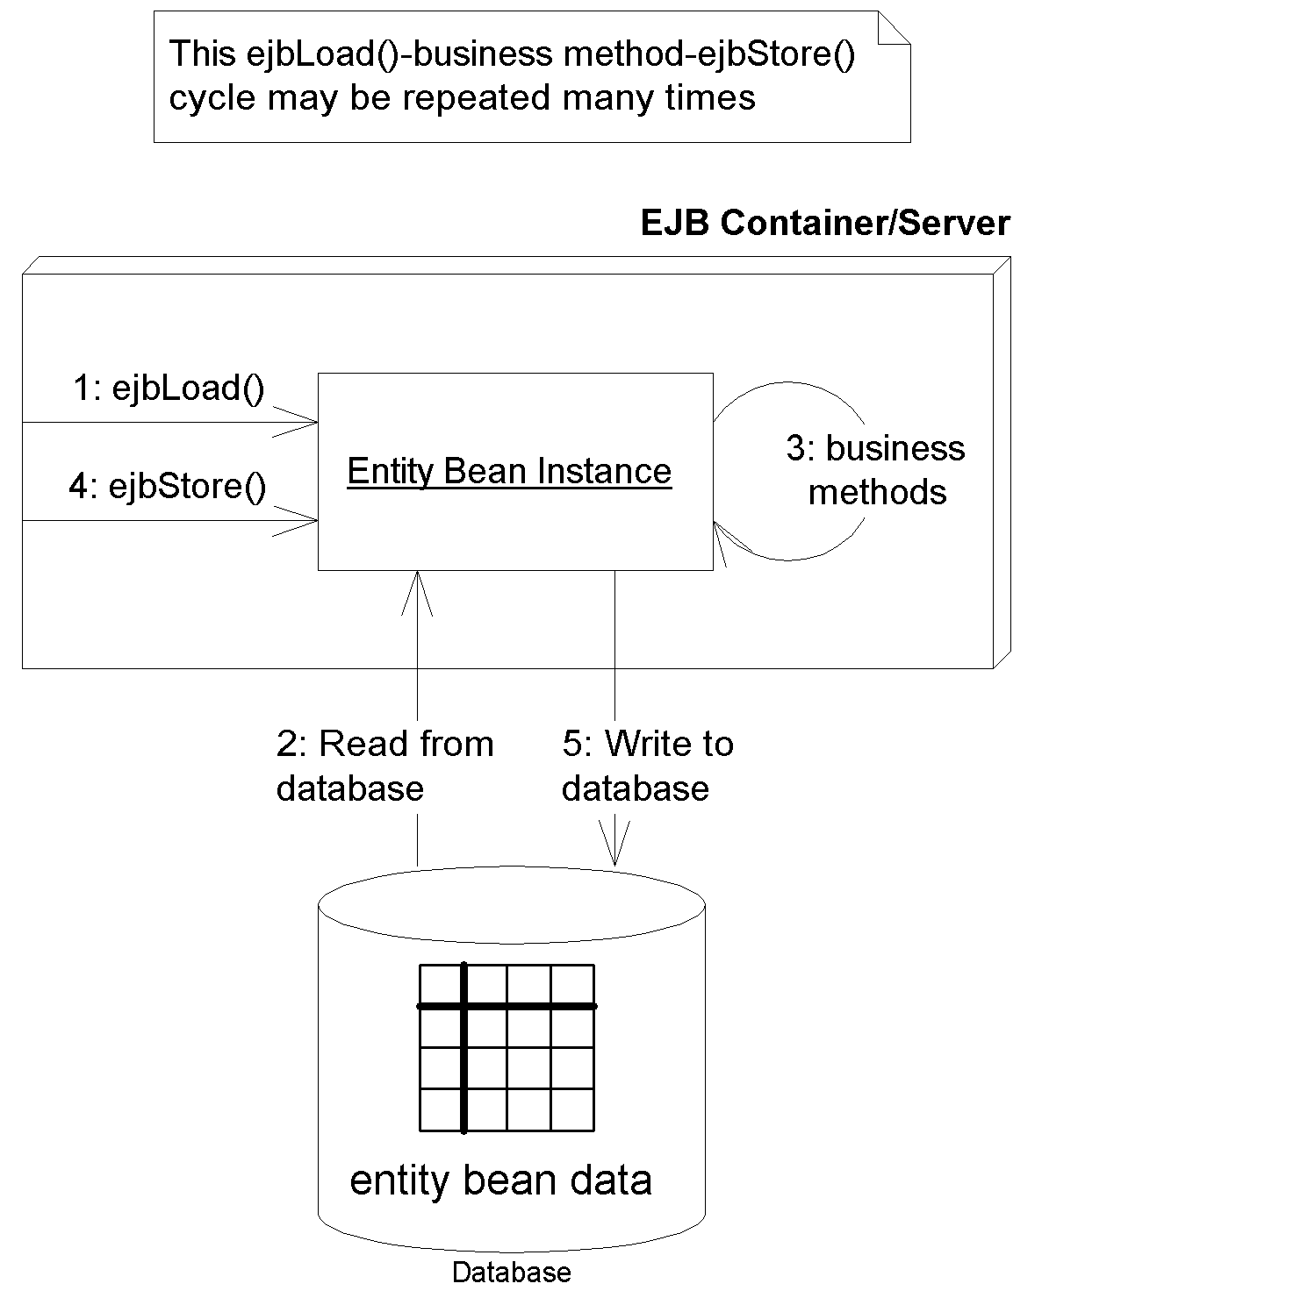
Figure X.X Loading and storing an entity bean
Your beans should be prepared to accept an ejbLoad() or ejbStore() call at almost any time (but not during a business method). The container automatically figures out when each of your instances needs to be refreshed depending on the current transactional state (see Chapter X). This means that you don't ever explicitly call your own ejbLoad() or ejbStore() methods. This is one of the advantages of EJB: You don't have to worry about synchronizing your objects with the underlying database. Rather, the EJB black box handles it for you. That is why you can think of the entity bean and the database as the same; there should never be a time when the two are transactionally out-of-sync.
Several Entity Bean Instances May Represent the Same Underlying Data
Let's consider the scenario where many threads of execution want to access the same database data simultaneously. In banking, interest might be applied to a bank account, while at the same time a company directly deposits a check into that same account. In E-Commerce, many different client browsers may be simultaneously interacting with a catalog of products.
To facilitate many clients accessing the same data, we'll need to design a high-performance access system to our entity beans. One possibility is if we allow many clients to share the same entity bean instance. That way, an entity bean could service many client requests simultaneously. While this is an interesting idea, it is not very appropriate for EJB. The reason for this is twofold. First, if we'd like an entity bean instance to service many concurrent clients, we'd need to make that instance thread-safe. Writing thread-safe code is difficult and error-prone. Remember that the EJB value proposition is rapid application development. Mandating that component vendors produce stable thread-safe code does not encourage this. Second, having multiple threads of execution makes transactions almost impossible to control by the underlying transaction system. Because of these reasons, EJB dictates that only a single thread can ever be running within a bean instance. With session beans, message-driven beans, as well as entity beans, all bean instances are single-threaded.
Mandating that each bean can service only one client at a time could result in performance bottlenecks. Because each instance is single-threaded, clients need to effectively run in lock-step, each waiting their turn to use a bean. This could easily grind performance to a halt in any large enterprise deployment.
To boost performance, we could allow containers to instantiate multiple instances of the same entity bean class. This would allow for many clients to concurrently interact with separate instances, each representing the same underlying entity data. Indeed, this is exactly what EJB allows containers to do. Thus, client requests do not necessarily need to run independently—they can now run simultaneously in several different bean instances.
Having multiple bean instances represent the same data now raises a new problem: data corruption. If many bean instances are representing the same underlying data, then we're dealing with multiple in-memory cached replicas. Some of these replicas could become stale, representing data that is not current.
To achieve entity bean instance cache consistency, each entity bean instance needs to be routinely synchronized with the underlying storage. The container synchronizes the bean with the underlying storage by calling the bean's ejbLoad() and ejbStore() callbacks, as described in the previous section.
The frequency with which beans are synchronized with an underlying storage is dictated by transactions, a topic we cover in Chapter X. Transactions allow each client request to be isolated from every other request. Transactions enable clients to believe they are dealing with a single in-memory bean instance, when in fact there are many instances behind the scenes. They give clients the illusion that they have exclusive access to data when in fact there are many clients all touching the same data.
Entity Bean Instances Can Be Pooled
Let's say you've decided to author your own EJB container/server. Your product is responsible for instantiating entity beans as necessary, with each bean representing data in an underlying storage. As clients connect and disconnect, you could create and destroy beans as necessary to service those clients.
Unfortunately, this is not a very scalable way to build an application server. Creation and destruction of objects is very expensive, especially if client requests come frequently. How can we save on this overhead?
One thing to remember is that an entity bean class describes the fields and rules for your entity bean, but it does not dictate any specific data. For example, an entity bean class may specify that all bank accounts have the following fields:
- The name of the bank account owner
- An account ID
- An available balance
That bean class can then represent any distinct instance of database data, such as a particular bank account record. The class itself, though, is not specific to any particular bank account.
Thus, to save precious time instantiating objects, entity bean instances are recyclable objects and may be pooled depending on your container's policy. The container may pool and reuse entity bean instances to represent different instances of the same type of data in an underlying storage. For example, a container could use a bank account entity bean instance to represent different bank account records. Thus, when you're done using an entity bean instance, that instance may be assigned to handle a different client's request and may represent different data. The container performs this by dynamically assigning the entity bean instance to different client-specific EJB objects. Not only does this save the container from unnecessarily instantiating bean instances, but this scheme saves on the total amount of resources held by the system. We show this in Figure X.X.
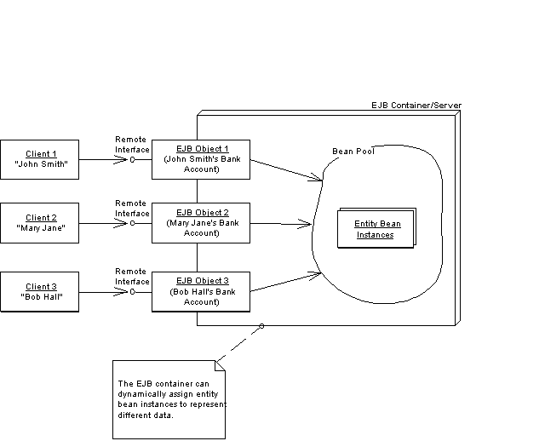
Figure X.X EJB container pooling of entity beans.
Instance pooling is an interesting optimization that containers may provide, and it is not at all unique to entity beans. As we saw in Chapter X, stateless session beans can also be recycled.
But as with stateful session beans, there are complications when reassigning entity bean instances to different EJB objects. When your entity bean is assigned to a particular EJB object, it may be holding resources such as socket connections. But when it's in the pool, it may not need that socket. Thus, to allow the bean to release and acquire resources, your entity bean class must implement two callback methods:
ejbActivate() is the callback that your container will invoke on your bean instance when transitioning your bean out of a generic instance pool. This process is called activation, and it indicates that the container is associating your bean with a specific EJB object and a specific primary key. Your bean's ejbActivate() method should acquire resources, such as sockets, that your bean needs when assigned to a particular EJB object. This is the same activation concept that we saw for stateful session beans in Chapter X.
ejbPassivate() is the callback that your container will invoke when transitioning your bean into a generic instance pool. This process is called passivation, and it indicates that the container is disassociating your bean from a specific EJB object and a specific primary key. Your bean's ejbPassivate() method should release resources, such as sockets, that your bean acquired during ejbActivate(). This is the same passivation concept that we saw for stateful session beans in Chapter X.
When an entity bean instance is passivated, it must not only release held resources but also save its state to the underlying storage—that way, the storage is updated to the latest entity bean instance state. To save the instance's fields to the database, the container invokes the entity bean's ejbStore() method prior to passivation. Similarly, when the entity bean instance is activated, it must not only acquire any resources it needs but also load the most recent data from the database. To load data into the bean instance, the container invokes the entity bean's ejbLoad() method after activation. This is shown in Figure X.X.
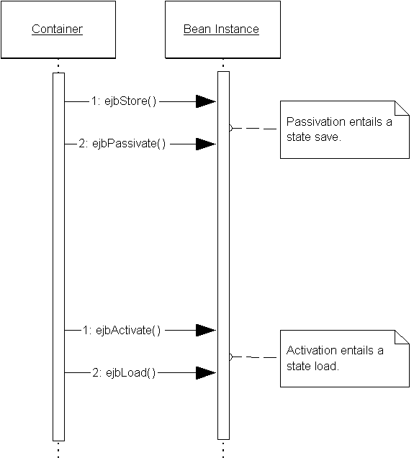
Figure X.X Passivation of entity beans entails a state save, and activation entails a state load.
If you think about it, entity beans are actually quite similar to stateful session beans. Both stateful session beans and entity beans can undergo passivation/activation. The big difference between the two is that entity beans have a separate ejbStore() method for saving state during passivation and a separate ejbLoad() callback for loading state during activation. We did not need these callbacks for stateful session beans because the container simply uses object serialization (or the equivalent) to persist stateful session bean fields. Entity beans are more complex, bonafied persistent objects—and naturally, they may need more complex ways of saving state than object serialization. An entity bean instance might use object/relational mapping via a relational database API, or it might persist itself to an object database using an object database API. That's why passivation/activation needs to rely on separate ejbLoad() and ejbStore() callbacks to deal with state persistence.
There Are Two Ways to Persist Entity Beans
Since entity beans map to a storage, someone needs to actually write the database access code.
A bean-managed persistent entity bean is an entity bean that must be persisted by hand. In other words, you as the component developer must write code to translate your in-memory fields into an underlying data store, such as a relational database or an object database. You handle the persistent operations yourself--including saving, loading, and finding data--within the entity bean. Therefore, you must write to a persistence API, such as JDBC or SQL/J. For example, with a relational database, your entity bean could perform an SQL INSERT statement via JDBC to stick some data into a relational database. You could also perform an SQL DELETE statement via JDBC to remove data from the underlying store.
EJB offers an alternative to bean-managed persistence: You can have your EJB container perform your persistence for you. This is called container-managed persistence. In this case, you'd usually strip your bean of any persistence logic. Then, you inform the container about how you'd like to be persisted by using the container's tools. The container then generates the data access code for you. For example, if you're using a relational database, the container may automatically perform SQL INSERT statements to create database data. Similarly, it will automatically perform SQL DELETE statements to remove database data, and it will handle any other necessary persistent operations. Even if you are not working with a relational database, you can have your container persist for you. If your container supports a non-relational persistent store, such as an object database or a VSAM file, the container will generate the appropriate logic as necessary. In fact, you can wait until deployment time before you setup the O/R mapping, which is great because you can write storage-independent data objects, and re-use them in a variety of enterprise environments.
Container-managed persistence reduces the size of your beans tremendously because you don't need to write JDBC code—the container handles all the persistence for you. Needless to say, this is a huge value-add feature of EJB. Of course, it still evolving technology. Once we've written a few entity beans, we'll review the trade-offs of bean-managed versus container-managed persistence (see Chapter X).
Creation and removal of entity beans differs from session beans
When you learned about session beans, you saw that session beans support methods for initialization as well as destruction. To initialize a session bean, the container calls session bean's ejbCreate() method, allowing the bean to prepare itself for use. Similarly, when a session bean is about to be destroyed, the container calls the bean's ejbRemove() method, allowing the bean to prepare itself for destruction.
With entity beans, initialization and destruction work a bit differently. Entity beans are a view into a database, and you should think of an entity bean instance and the underlying database as one and the same (they are routinely synchronized). Because they are one and the same, the initialization of an entity bean instance should entail initialization of database data. Thus, when an entity bean is initialized in memory during ejbCreate(), it naturally makes sense to create some data in an underlying database that correlates with the in-memory instance. That is exactly what happens with entity beans. When a bean-managed persistent entity bean's ejbCreate() method is called, the ejbCreate() method is responsible for creating database data. Similarly, when a bean-managed persistent entity bean's ejbRemove() method is called, the ejbRemove() method is responsible for removing database data. If container-managed persistence is used, the container will modify the database for you, and you can leave these methods empty of data access logic.
Let's take a look at this in more detail.
Understanding how entity beans are created and destroyed
In EJB, remember that clients don't directly invoke on beans—they invoke an EJB object proxy. The EJB object is generated through the home object. Therefore, for each ejbCreate() method signature you define in your bean, you must define a corresponding create() in the home interface. The client calls the home object's create(), which delegates to your bean's ejbCreate().
For example, let's say you have a bank account entity bean class called AccountBean, with a remote interface Account, home interface AccountHome, and primary key class AccountPK. Given the following ejbCreate() method in AccountBean:
public AccountPK ejbCreate(String accountID, String owner) ...
you must have this create() in your home interface (notice there is no "ejb" prefix):
public Account create(String accountID, String owner) throws ...
Notice that there are two different return values here. The bean instance returns a primary key (AccountPK), while the home object returns an EJB object (Account). This makes sense—the bean returns a primary key to the container (that is, to the home object) so that the container can identify the bean. Once the home object has this primary key, it can generate an EJB object and return that to the client. We show this process more rigorously with the sequence diagram in Figure X.X.
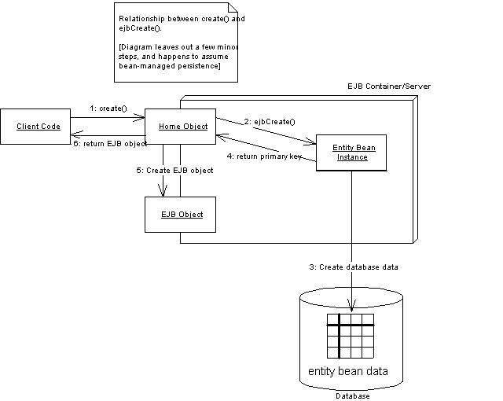
Figure X.X Creating an entity bean and EJB object.
To destroy an entity bean's data in a database, the client must call remove() on the EJB object or home object. This method causes the container to issue an ejbRemove() call on the bean. We show this in Figure X.X.
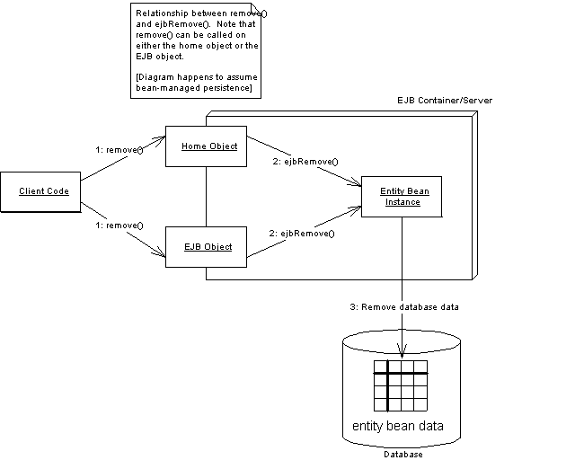
Figure X.X Destroying an entity bean's data representation.
Note that ejbRemove() does not mean the in-memory entity bean instance is going to be destroyed—ejbRemove()destroys only database data. The bean instance can be recycled to handle a different database data instance, such as a bank account bean representing different bank accounts.
ejbRemove() is a required method of all entity beans, as it is of session beans, and it takes no parameters. There is only one form of ejbRemove(). With entity beans, ejbRemove() is not called if the client times out because the lifetime of an entity bean is longer than the client's session.
Entity beans can be found
Because entity bean data is uniquely identified in an underlying storage, entity beans can also be found rather than created. Finding an entity bean is analogous to performing a SELECT statement in SQL. With a SELECT statement, you're searching for data from a relational database store. When you find an entity bean, you're searching a persistent store for some entity bean data. This differs from session beans because session beans cannot be found—they are not permanent objects, and they live and die with the client's session.
You can define many ways to find an entity bean. You list these ways as methods in your entity bean home interface. These are called finder methods. Your home interface exposes finder methods in addition to methods for creating and destroying entity beans. This is the one big difference between an entity bean's home interface and a session bean's home interface—session bean home interfaces do not have finder methods.
You can modify entity bean data without using EJB
Usually, you will create, destroy, and find entity bean data by using the entity bean's home object. But you can interact with entity beans another way, too: by directly modifying the underlying database where the bean data is stored. For example, if your entity bean instances are being mapped to a relational database, you can simply delete the rows of the database corresponding to an entity bean instance (see Figure X.X). You can also create new entity bean data and modify existing data by directly touching the database. This may be necessary if you have an investment in an existing system that touches a database directly.
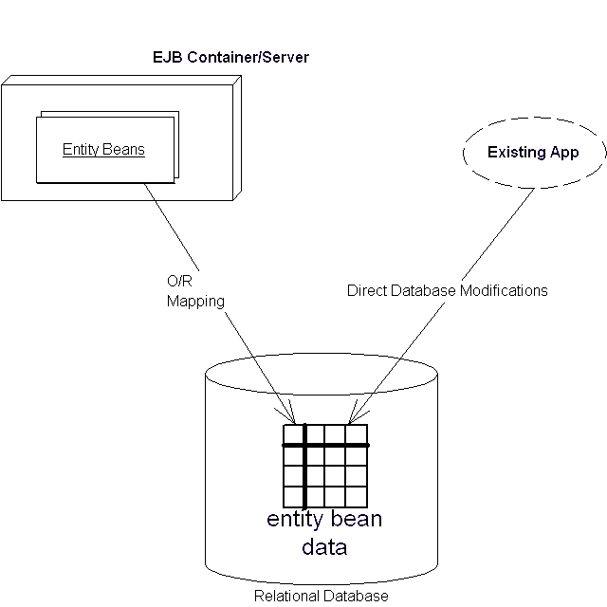
Figure X.X Modifying an entity bean's database representation manually.
Entity Contexts
As you learned in Chapter X, all enterprise beans have a context object that identifies the environment of the bean. These context objects contain environment information that the EJB container sets. Your beans can access the context to retrieve all sorts of information, such as transaction and security information. For session beans, this context's interface is javax.ejb.SessionContext, while for MessageDriven beans, it is javax.ejb.MessageDrivenContext. For entity beans, the interface is javax.ejb.EntityContext. Both session contexts and entity contexts extend the more generic javax.ejb.EJBContext interface.
We provide a refresher of the javax.ejb.EJBContext methods in Source X.X. Appendix X explains the meaning of each method.
public interface javax.ejb.EJBContext {
public javax.ejb.EJBHome getEJBHome();
public javax.ejb.EJBLocalHome getEJBLocalHome();
public java.security.Principal getCallerPrincipal();
public boolean isCallerInRole(java.lang.String);
public void setRollbackOnly();
public boolean getRollbackOnly();
}
Source X.X The javax.ejb.EJBContext interface
Entity contexts add two new methods on top of the generic EJB context, shown in Source X.X.
public interface javax.ejb.EntityContext
extends javax.ejb.EJBContext {
public javax.ejb.EJBLocalObject getEJBLocalObject();
public javax.ejb.EJBObject getEJBObject();
public java.lang.Object getPrimaryKey();
}
Source X.X The javax.ejb.EntityContext interface.
Let's look at each of these methods in more detail.
getEJBLocalObject() / getEJBObject()
Call this to retrieve the current, client-specific EJB object that is associated with the entity bean. Remember that clients invoke on EJB objects, not on entity beans directly. Therefore you can use the returned EJB object as a way to pass a reference to yourself, simulating the this argument in Java. getEJBObject() has the same functionality as session beans. getEJBLocalObject() is the same, except it gets the more optimized EJB local object described in Chapter X.
getPrimaryKey()
getPrimaryKey() is new to entity beans. It retrieves the primary key that is currently associated with this entity bean instance. Primary keys uniquely identify an entity bean. When an entity bean is persisted in storage, the primary key can be used to uniquely retrieve the entity bean because you can never have two entity bean database data instances that have the same primary key.
Why would you ever want to call getPrimaryKey()? You'd call it whenever you want to figure out with which database data your instance is associated. Remember that entity bean instances can be reused and pooled, as we saw in Figure X.X. When the container wants to switch an entity bean instance from one data instance to another, the container needs to passivate and activate that entity bean instance. When this happens, your bean instance may switch to a different data instance and thus a different primary key. But your entity bean instance is never told this explicitly when it's activated. Rather, your entity bean must perform a getPrimaryKey() callback to the entity context to figure out what data it should be dealing with.
Thus, when you have an entity bean that's performing any persistent work (with bean-managed persistence), you should be calling getPrimaryKey() whenever you need to figure out what data you're bean is associated with. This is very useful, for example, in the following methods:
ejbLoad(). If you recall, ejbStore() and ejbLoad() are bean callbacks to synchronize a bean instance with an underlying storage. ejbStore() saves data to storage, and ejbLoad() reads data from storage. When the container calls ejbStore(), your bean knows exactly what data to save because the bean instance has the data in memory. But when the container calls ejbLoad(), how does your bean know what data to load? After all, bean instances are pooled and can be dynamically assigned to different data. The answer is to use getPrimaryKey(); it will tell you what primary key you should be looking for in the underlying storage when loading database data.
ejbRemove(). If you recall, ejbCreate() and ejbRemove() are callbacks for creating and removing data from an underlying storage, respectively. When the container calls ejbCreate(), your bean knows exactly what data to create in the database because your bean has received information in the parameters of ejbCreate(). But when the container calls ejbRemove(), how does your bean know what data to remove? Because bean instances are pooled and dynamically assigned to handle different data instances, you might be deleting the wrong data. Thus you must call getPrimaryKey() to figure out what data, keyed on the primary key, your bean should remove from the database.
Thus, it's always important to consider bean pooling when writing your enterprise beans, and getPrimaryKey() is the key to always knowing what data your bean is representing.
Summary
In this chapter, we've taken the first steps toward developing with entity beans. We started by learning about various persistence mechanisms, including object serialization, object/relational mapping, and persistence to pure object databases. We then looked at exactly what an entity bean is, and we saw the files included with an entity bean component. Next, we used our knowledge of session beans as a basis for learning entity beans. After surveying their features, we took a look at entity contexts.
But the best is yet to come—in the coming chapters, we'll learn hands-on about entity bean programming. Chapter X starts off by explaining bean-managed persistent entity beans, and it guides you through the steps in developing them using JDBC. Chapter X then continues with container-managed persistent entity beans. Then, in Chapter X we'll do a full comparison of the promises and realities of the two entity bean programming models. By the time you're through, you'll be armed to create your own entity beans in enterprise deployments.

